**United States Magistrate Judge Jon A. York**

**Welcomed as Memphis Bar Association 2024 Fellow**

**Memphis Area Attorneys and Judges Honored for Service to the Community & Legal Profession**

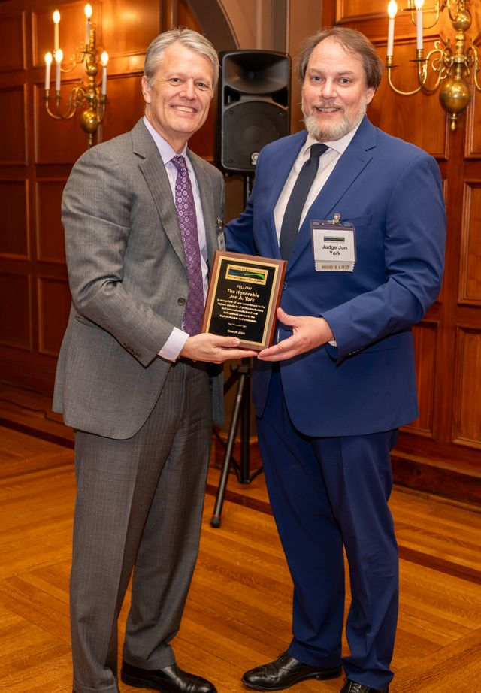The Memphis Bar Foundation 2024 Fellows Reception was held recently at The University Club of Memphis. The Memphis Bar Foundation is the charitable foundation affiliated with the Memphis Bar Association. **United States Magistrate Judge Jon A. York**joins this prestigious group of individuals recognized for their service to the legal profession and the community.

“Being named a Memphis Bar Foundation Fellow is a tremendous honor,” says Terrence Reed, Fellows Selection Committee Chair. “Approximately 1% of Memphis area attorneys are invited to join the Memphis Bar Foundation Fellows each year.”

The Foundation annually nominates attorneys and judges to become Fellows.  Nominees are chosen based on their devoted and distinguished service to the legal profession and the administration of justice and their adherence to the highest standards of professional ethics and personal conduct. Annually, the Foundation awards grants to non-profit organizations to support law-related projects and programs that fall within its mission. These grants would not be possible without the financial support of our Foundation’s Fellows.

***Memphis Bar Foundation 2024 Fellows***

The Honorable Carlyn L. Addison  
Tricia E. Adrian  
Adam S. Baldridge  
Samantha E. Bennett  
Natalie M. Bursi  
The Honorable Carol J. Chumney  
Laura L. Deakins  
Robert A. Donati  
Brian M. Glass  
Eiko C. Harris  
Michael R. Hess  
The Honorable Christopher Ingram, Jr.  
Timothy R. Johnson  
The Honorable James Jones, Jr.  
Geoffrey A. Lewis  
Richard Mattern  
Melody McAnally  
Asia Diggs Meador  
Patrick H. Morris  
Janelle Crandall Osowski  
Michael R. Parham  
Toni C. Parker  
The Honorable Mitzi H. Pollard  
The Honorable Sheila B. Renfroe

Laquita Stokes  
Rebekka Freeman Terrell  
Nicholas L. Vescovo  
Joshua A. Wallis  
Jesyca Westbrook-Pettes  
Shannon Wiley  
Todd Williams  
Mary Wu Tullis

The mission of the Memphis Bar Foundation is to promote philanthropy among members of the Bar; advocate and support public awareness of the legal system, promote social justice and legal education; and encourage and recognize professionalism among members of the Bar.